# **Cosmic Bigness**

### On Doing Something Big and Being Someone Big

Zoe's avatar

[Zoe](https://substack.com/@zoeffc)

Mar 07, 2025

3

[1](https://femmefuturescooperative.substack.com/p/cosmic-bigness/comments)

1

Share

Hi there,

Here’s a fun fact about me: I have wanted to be an entrepreneur my whole life. As a kid, I did lemonade stands and dog treat sales. I wrote novels and looked into how to find literary agents. Then middle school and puberty struck and suddenly I became self-conscious about creating.

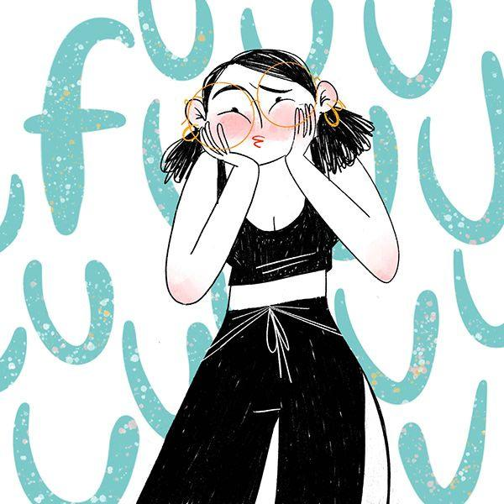

Art by [Ipek Konak](https://www.behance.net/ipek_konak)

Subscribed

Here’s one thing about me: I want to do something big; I want to be someone big. I was reading a book last week where the character was seemingly destined for *bigness*, “cosmic bigness” as the author puts it. She is a star from the moment that she walks onto her first stage in high school — she has that X factor — but instead of pursuing acting, she becomes a world-renowned author and marries an A-list actress who stars in the movie adaptation of the book. Like I said, destined for bigness. I want to be destined for bigness and I am chomping at the bit to uncover what that might be.

I did NaNoWriMo (National Novel Writing Month) throughout middle and high school, but I didn’t tell anyone aside from my closest friends. But here is where things change: one day in eighth grade, I was writing my novel and a boy in my class sat down next to me. He asked me what I was doing, and without shame I responded “I am writing a novel.” He laughed at me. I wanted to hit rewind and unsay it. When we were graduating from high school four years later, he asked me about that novel. I hadn’t finished it. I had kind of given up on writing entirely by that point and I had certainly learned that to be that ambitious was not a great look on me.

Luckily, my high school graduation is a few years behind me at this point and I have grown a lot since then. In the in between years, I got more itchy about that need to be someone - to do something.

Well, you cannot convince the world that you *are* someone without first doing something. I committed to doing work that would make the world better. I worked in nonprofits for years as an intern and formally for about a year after college, literally saving the rainforest. It felt good doing *something*. But the circumstances changed and suddenly the doing good of it all was out weighed by the “I really do not deserve to be treated like this” of it all, so I left that doing, and transitioned to a less “save the rainforests” something. My something has been slipping.

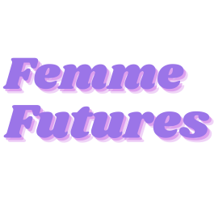

Get more from Zoe in the Substack app

Available for iOS and Android

[Get the app](https://substack.com/app/app-store-redirect?utm_campaign=app-marketing&utm_content=author-post-insert&utm_source=femmefuturescooperative)

But then there was Femme Futures. Now, I am not an obsessive person, and maybe you have to be obsessive in order to turn an idea into a real thing. Well, it may not be a Justin Bieber level obsession, but I can go on and on and on about doing what feels good and what is good for the world. I want to pour as much into this as I can manage and have it become part of the mark that I leave on this world.

Here’s where the challenge lies:

* I still think that my ambition is shameful, so I really struggle to self-promote. Before writing this note that you are reading, I started working on a note about how to share my work, how to pledge your support for Femme Futures, and how to make this project financially sustainable. Writing that made me so anxious that I changed courses.
* I am not obsessive enough and what if that means that I don’t care enough. Don’t get me wrong, I love this space, but there are weeks where I don’t want to write a note. I give myself a plethora of excuses not to write, all ranging in validity, but then I look over into the corner and see the eight-year old version of me who is watching my type away in awe.
* I have doubts. Am I barking up the wrong tree? Is this the right forum or platform for the Femme Futures Cooperative that I have dreamed up? Is there a need for this content in the world, or am I redundant? Am I the right person to be writing these notes? But I show up anyway — I have no idea if that is the right call.

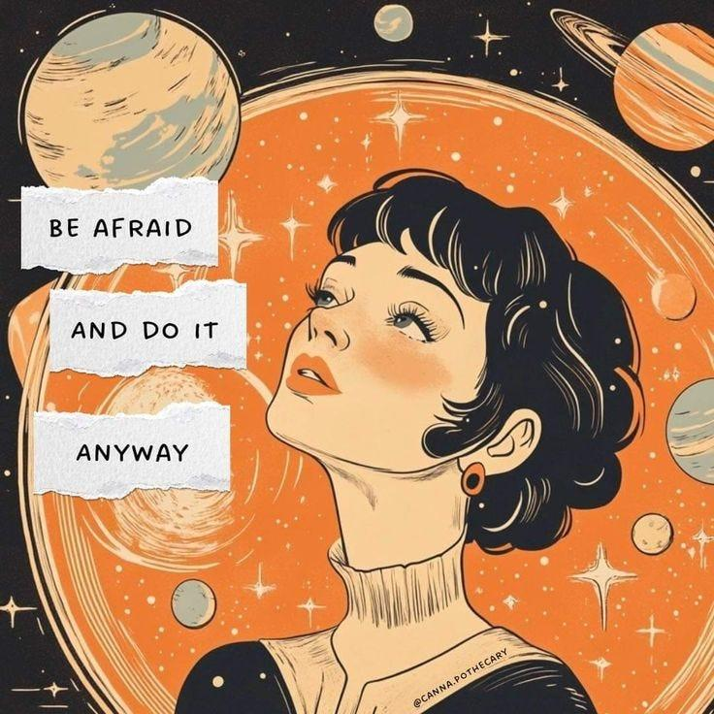

art by @canna.pothecary

Oftentimes, Substack articles are formatted in an advisory tone, which I appreciate and even do myself sometimes, but so often, I am seeking advice as I write. I write to you because I want you to see someone else who is feeling around in the dark and freaking the fuck out. My mind is filled with insecurities and anxieties, but also with ideas and dedication.

This week, I pushed myself hard. You probably saw my last newsletter, explaining the benefits of becoming a paid subscriber to the Femme Futures Cooperative. That note has been looming over me, waiting to be written. I swear, my hand was trembling as I hit send, knowing how vulnerable it made me feel to ask you all if you care about what I write. But you know what? I care about this, and I don’t want to stop doing hard things. So here goes:

If you like it here, hit one of the pledge your support buttons in this article and you will be added to a list of people who would be keen to pay for bonus Femme Futures content, and support my writing. You will not be charged! It is just an indication of interest. Bonus content will include whatever we want it to. I can do podcasts or videos, I could write bonus newsletters, I could have a chat with you all.

In the meantime though, if you want bonus content, [download the Substack app](https://substack.com/app/app-store-redirect?utm_campaign=app-marketing&utm_content=author-post-insert&utm_source=femmefuturescooperative) and follow me there for my random mid-week thoughts.

All the best,

Zoe

Subscribed